**Project 2: How to create new instance using AMI**

**1.Creating Image**

**Steps:**

**1. To create image using AMI, go to EC2 and click on instances.**

**2. Select the instance that is created before and click on action.**

**3. In action, select image and template. In image and template, select create images.**

**4. Give name as anu-server-backup and description to the instances.**

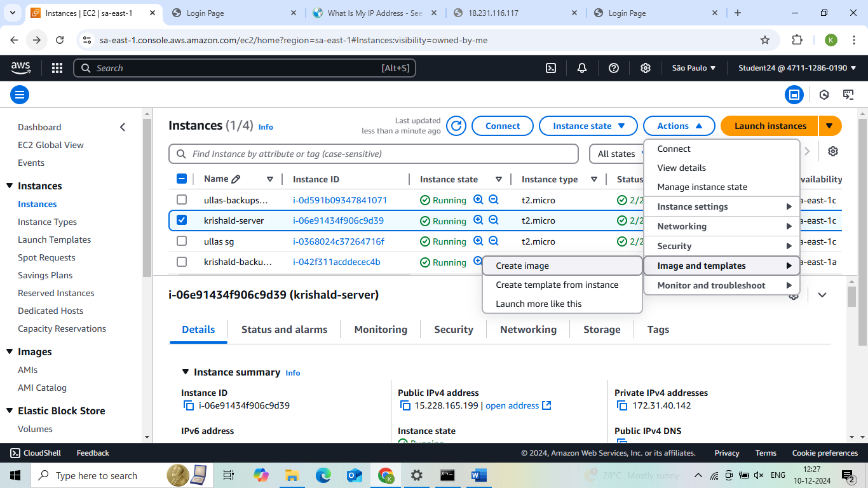

**2.AMI Summary**

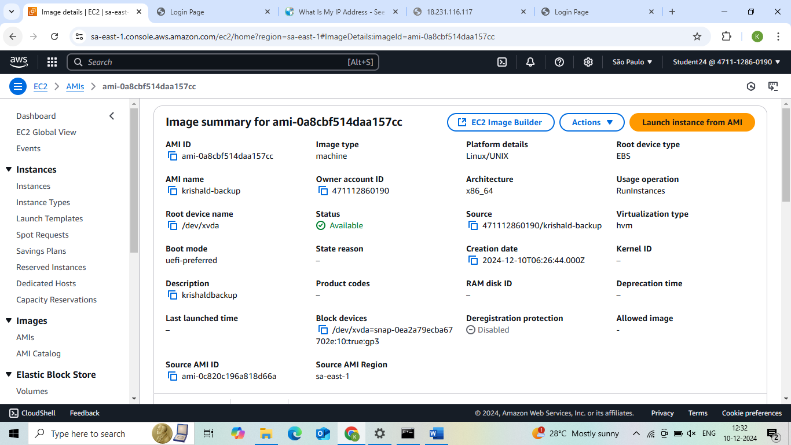

**3. After launching the backup server**

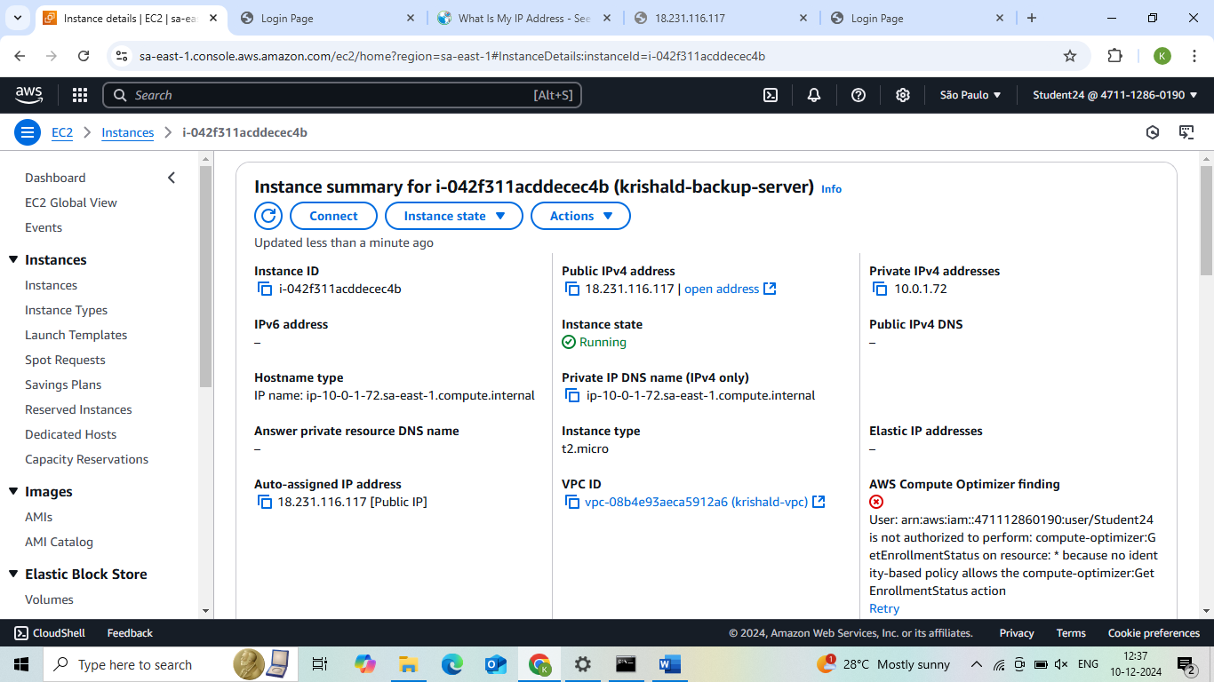

**4. Final Result**

